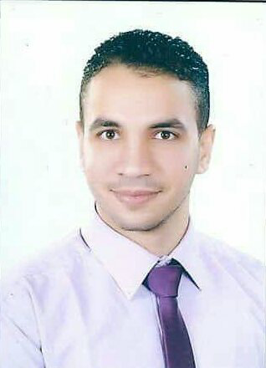

Mohamed samy
Accountant
Phone: 01289136632
Email: Mohamedsamy268@gmail.com
Address: Damietta, Egypt
Date of birth: 1 september 1994
Single
Military : exempted

Objective
An accountant seeking an apportunity in suitable company to enhance my skills and knowledge .
Ready to travel any where and any time

Education
Bachelor of commerce
Damietta university
Graduation: 2017
General Grade: Good.

Training

certificate of experience from the international accounting group for one year
Now work in my bed factory for manufacturing of matresses as an accountant

Current Activities

postgraduated in professional financial accounting diploma
Professional financial accounting course
NIEC certificate in the field of English Grant

Key Skills
- Good Communication and organizational Skills.
- Efficiency to work alone , with team and Can Deals With different Minds .
- Ability to work under pressure With different Environment.
- Ability To Analysis Problems and Solve it.

Computer Skills
- Microsoft office.
- Quick Books
- Accounting Excel
- Peachtree
- Design Software:
· Photoshop )Medium) .
- Programming Languages (Visual Basic).

REFERENCE WILL BE PROVIDED UPON REQUEST

